Practical 5 Part II

**What is a Join?**

A **JOIN** combines records from two or more tables using a related column.

**Types of Joins:**

1. **INNER JOIN** → Returns only matching records.

2. **LEFT JOIN** → Returns all records from the left table and matching records from the right table.

3. **RIGHT JOIN** → Returns all records from the right table and matching records from the left table.

4. **FULL OUTER JOIN** → Returns all records from both tables (not available in MySQL).

5. **CROSS JOIN** → Returns the Cartesian product of both tables. 6. **SELF JOIN** → Joins a table to itself.

**1. Customer Table**

|  |  |  |
| --- | --- | --- |
| **Column** | **Data Type** | **Constraints** |
| customer_id | NUMBER (PK) | PRIMARY KEY,  AUTO-INCREMENT |
| name | VARCHAR2(100) | NOT NULL |
| email | VARCHAR2(100) | UNIQUE |
| phone | VARCHAR2(15) | NOT NULL |
| address | VARCHAR2(255) | NULLABLE |

**2. Product Table**

|  |  |  |
| --- | --- | --- |
| **Column** | **Data Type** | **Constraints** |
| product_id | NUMBER (PK) | PRIMARY KEY |
| name | VARCHAR2(100) | NOT NULL |
| category | VARCHAR2(50) | NOT NULL |
| price | DECIMAL(10,2) | NOT NULL |
| stock_quantity | INT | NOT NULL |

**3. Order_Details Table**

|  |  |  |
| --- | --- | --- |
| **Column** | **Data Type** | **Constraints** |
| order_id | NUMBER (PK) | PRIMARY KEY |
| customer_id | NUMBER (FK) | FOREIGN KEY REFERENCES Customer(customer_id) |
| order_date | DATE | NOT NULL |
| total_amount | DECIMAL(10,2) | NOT NULL |

**4. Order_Item Table**

|  |  |  |
| --- | --- | --- |
| **Column** | **Data Type** | **Constraints** |
| order_id | NUMBER (FK) | FOREIGN KEY REFERENCES Order_Details(order_id) |
| product_id | NUMBER (FK) | FOREIGN KEY REFERENCES Product(product_id) |
| quantity | INT | NOT NULL |
| subtotal | DECIMAL(10,2) | NOT NULL |

**5. Employee Table**

|  |  |  |
| --- | --- | --- |
| **Column** | **Data Type** | **Constraints** |

|  |  |  |
| --- | --- | --- |
| employee_id | NUMBER (PK) | PRIMARY KEY |
| name | VARCHAR2(100) | NOT NULL |
| role | VARCHAR2(50) | NOT NULL |
| salary | DECIMAL(10,2) | NOT NULL |
| hire_date | DATE | NOT NULL |

**Examples of Joins**

**INNER JOIN: Get order details with customer names**

SELECT o.order_id, c.name, o.order_date, o.total_amount FROM Order_Details o

INNER JOIN Customer c ON o.customer_id = c.customer_id; 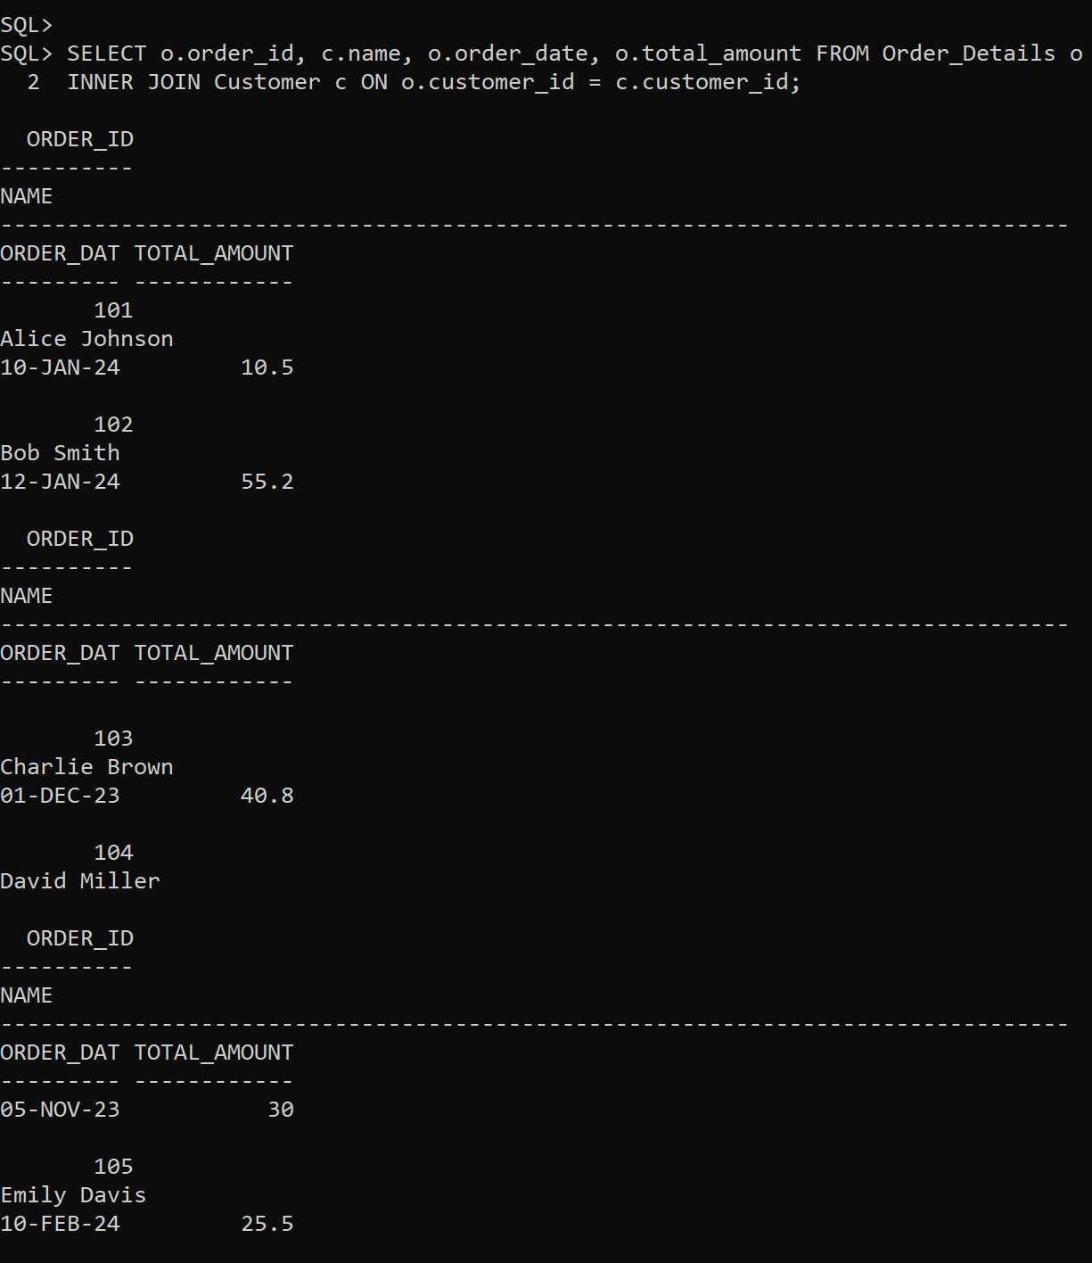

**INNER JOIN: Retrieve product names and their order quantities** SELECT p.name, oi.quantity

FROM Order_Item oi

INNER JOIN Product p ON oi.product_id = p.product_id; 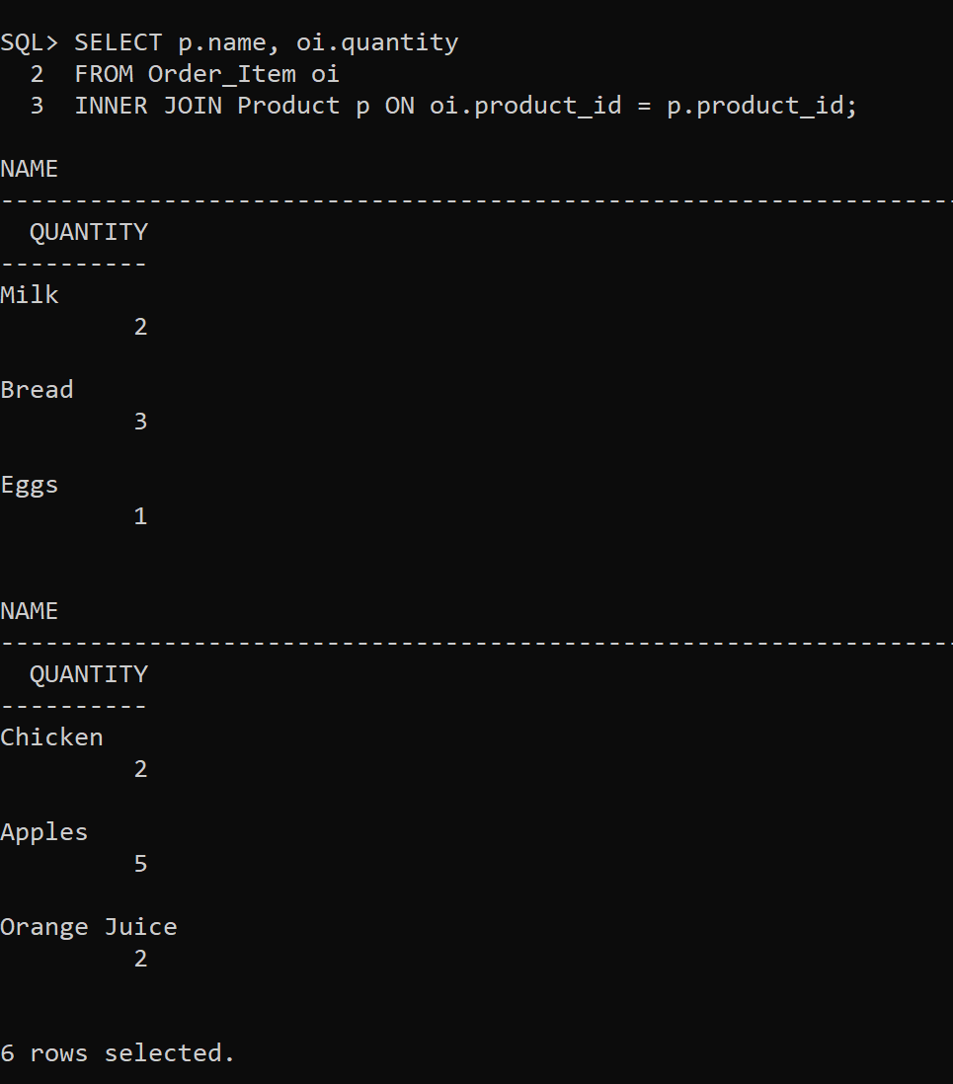

**LEFT JOIN: Get all customers and their orders (including those who never ordered)**

SELECT c.name, o.order_id, o.total_amount

FROM Customer c

LEFT JOIN Order_Details o ON c.customer_id = o.customer_id; 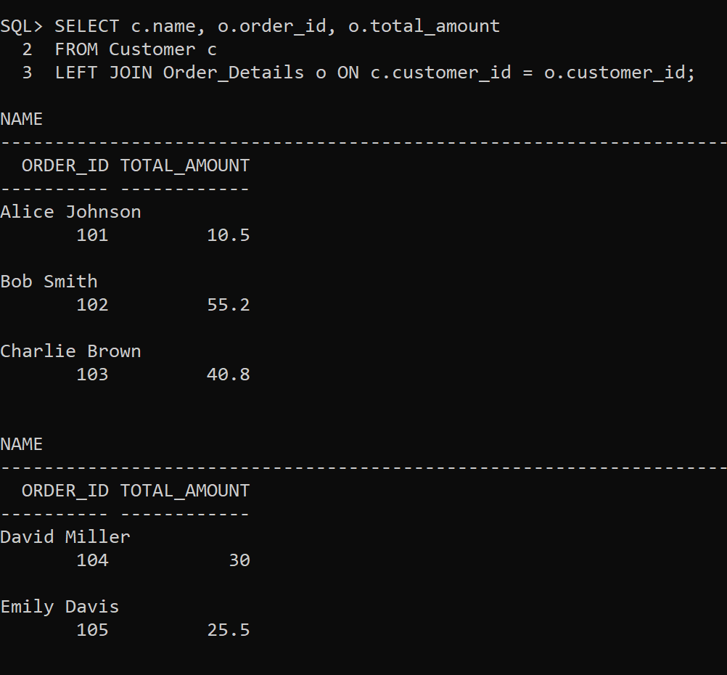

**LEFT JOIN: Retrieve all products and their order details (including those not ordered yet)**

SELECT p.name, oi.quantity

FROM Product p

LEFT JOIN Order_Item oi ON p.product_id = oi.product_id; 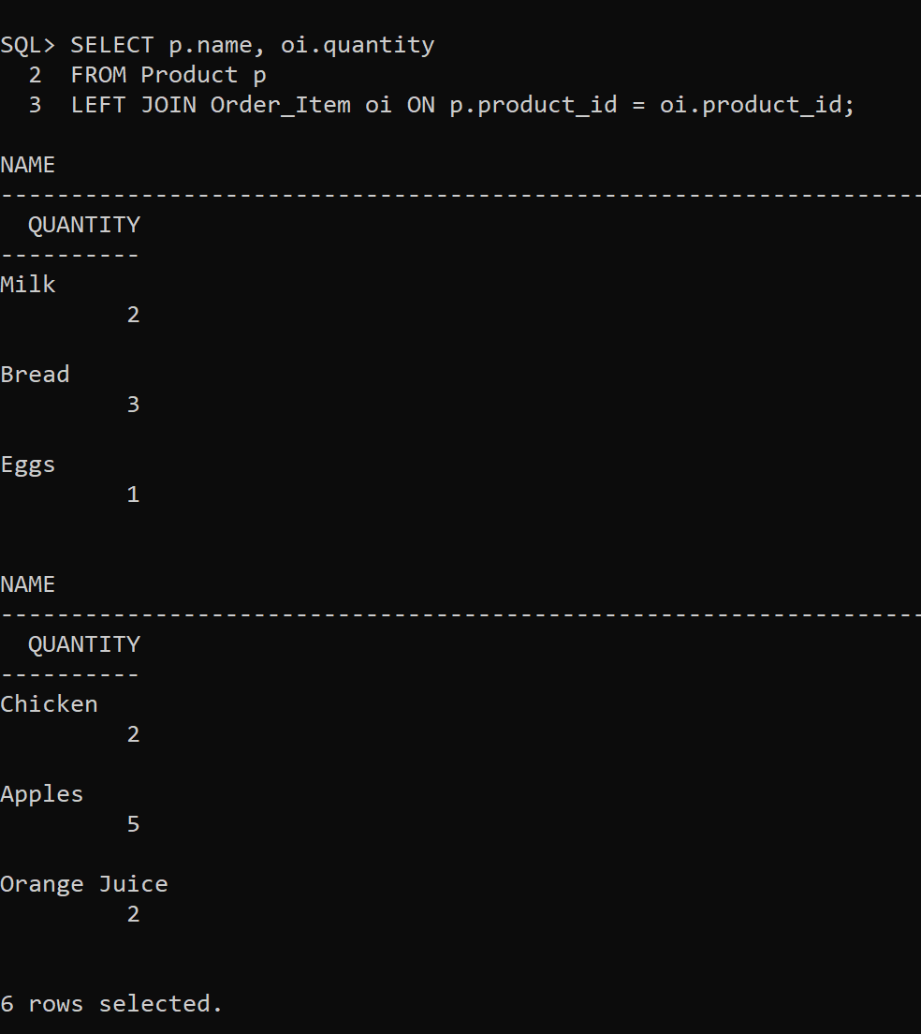

**RIGHT JOIN: Get all orders with or without employee assigned** SELECT o.order_id, e.name AS employee_name

FROM Order_Details o

RIGHT JOIN Employee e ON o.customer_id = e.employee_id; 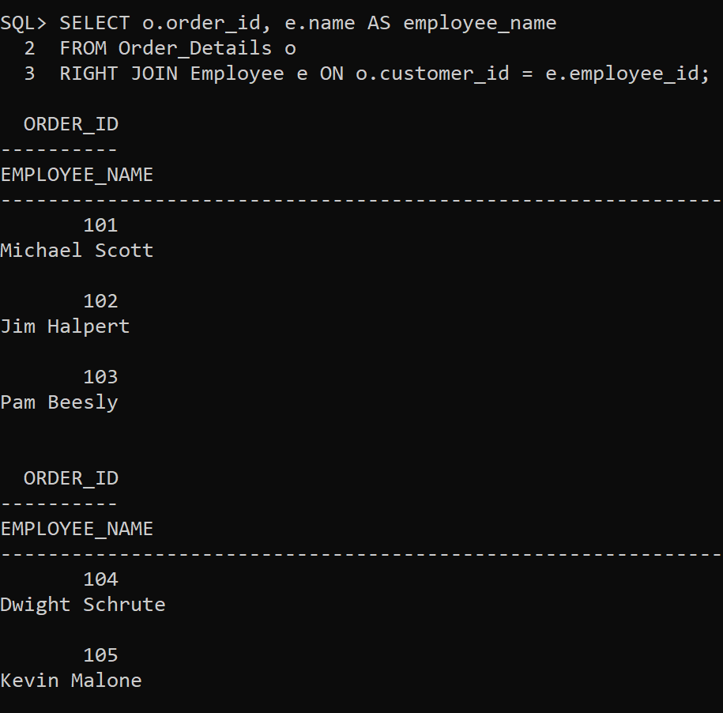

**RIGHT JOIN: Retrieve employees who processed orders**

SELECT e.name, o.order_id

FROM Employee e

RIGHT JOIN Order_Details o ON e.employee_id = o.customer_id; 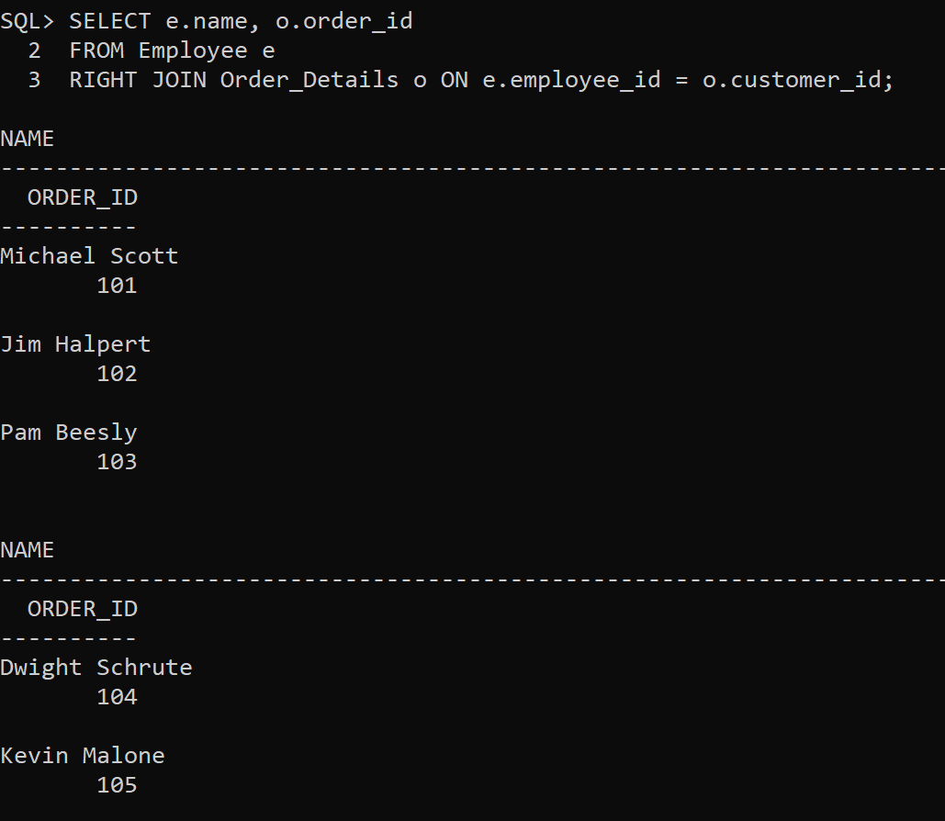

**FULL OUTER JOIN: Get all customers and orders (Oracle SQL only)** SELECT c.name, o.order_id, o.total_amount

FROM Customer c

FULL OUTER JOIN Order_Details o ON c.customer_id = o.customer_id; 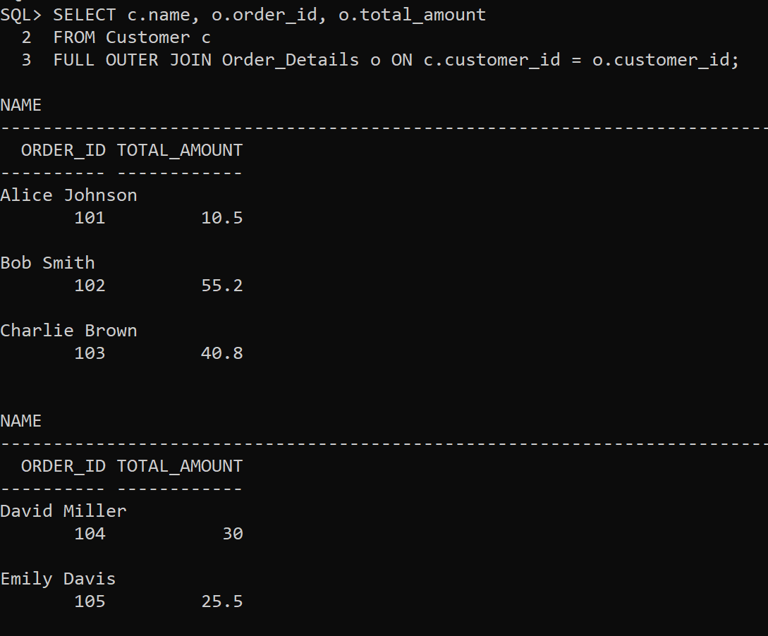

**CROSS JOIN: Show all possible employee-product assignments** SELECT e.name AS employee, p.name AS product

FROM Employee e

CROSS JOIN Product p; 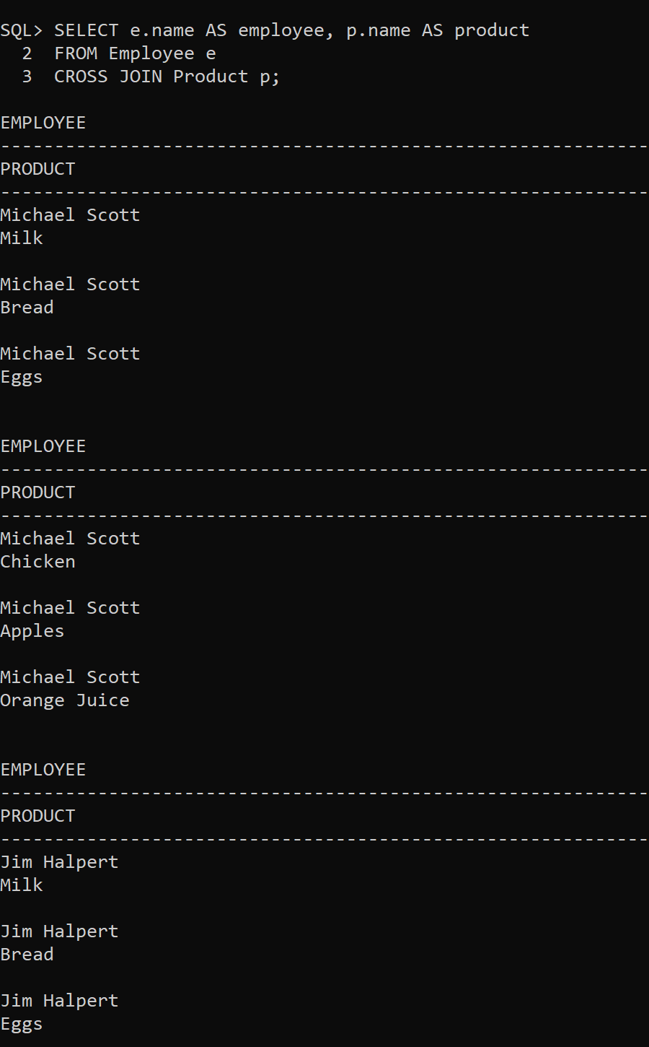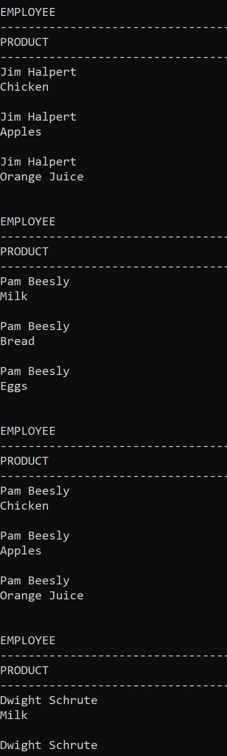

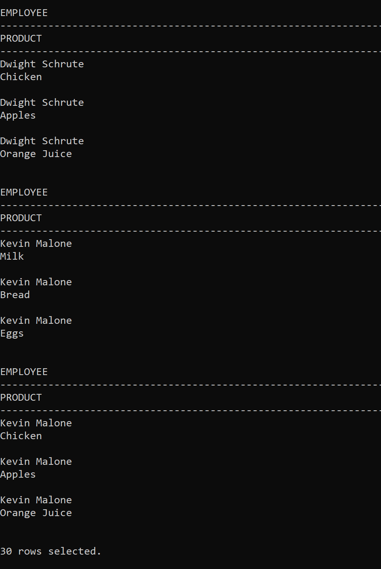

**SELF JOIN: Find employees earning more than their colleagues**

SELECT e1.name AS Employee, e2.name AS Colleague, e1.salary FROM Employee e1

JOIN Employee e2 ON e1.salary > e2.salary; 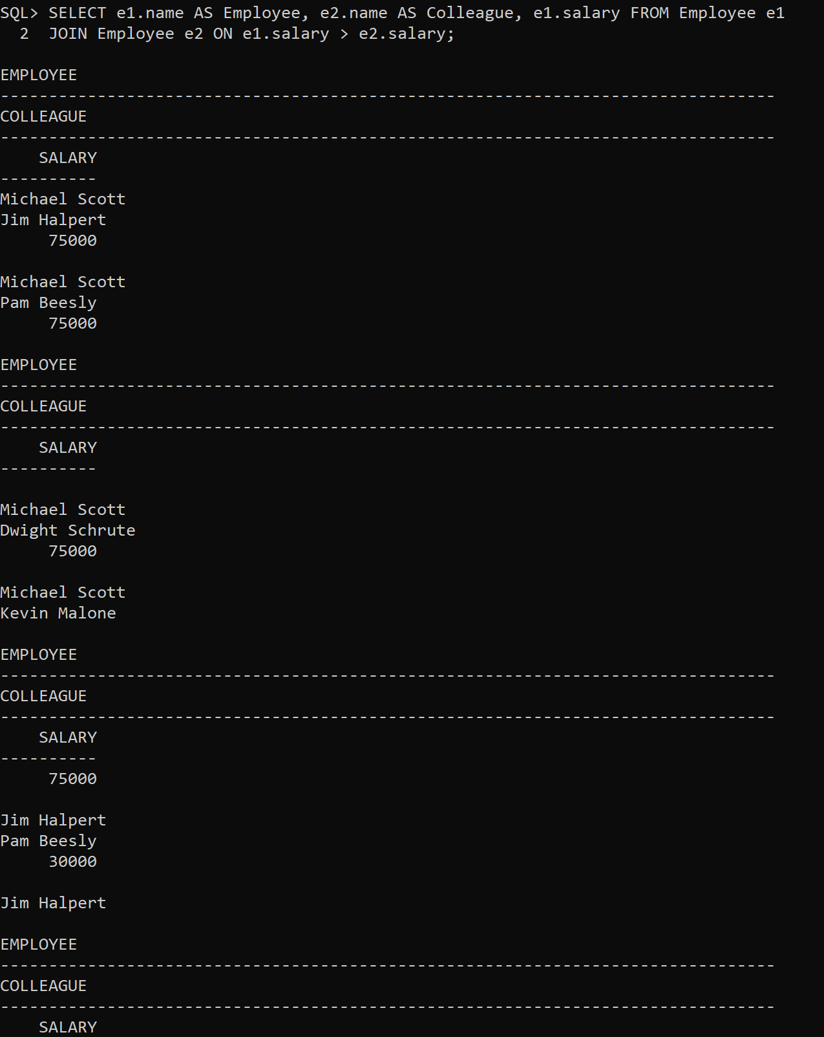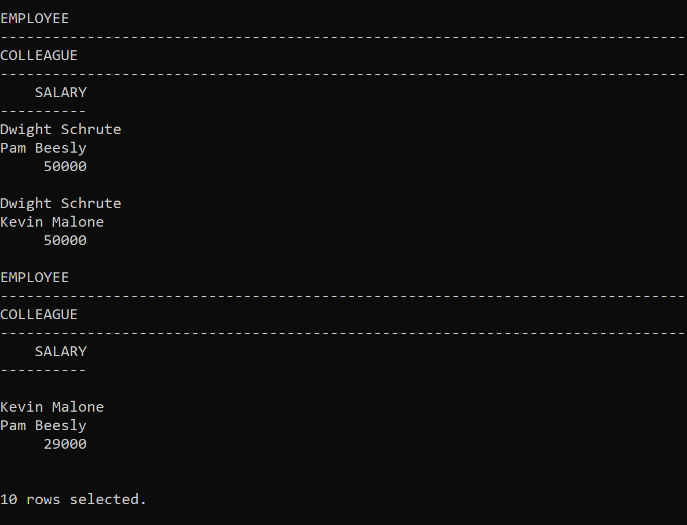

**SELF JOIN: Find employees working under the same manager**

SELECT e1.name AS Employee, e2.name AS Manager FROM Employee e1

JOIN Employee e2 ON e1.role = 'Cashier' AND e2.role = 'Manager'; 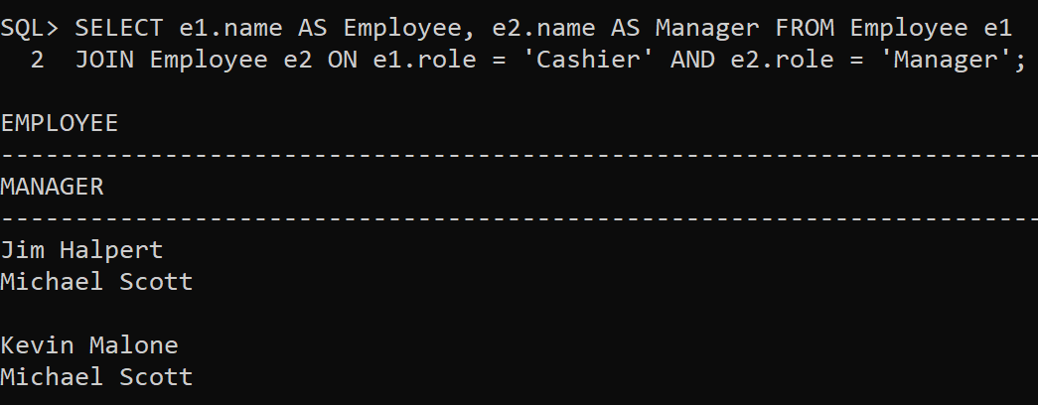

**Joins Tasks**

1. Retrieve **customer names** along with their orders.

**Join Type**: **INNER JOIN**

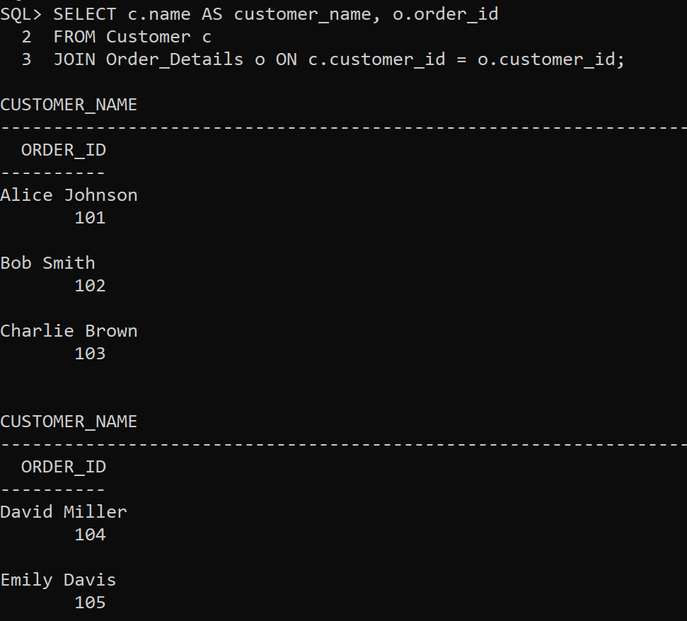

2. Show **product names** and their **order quantities**.

**Join Type**: **INNER JOIN**

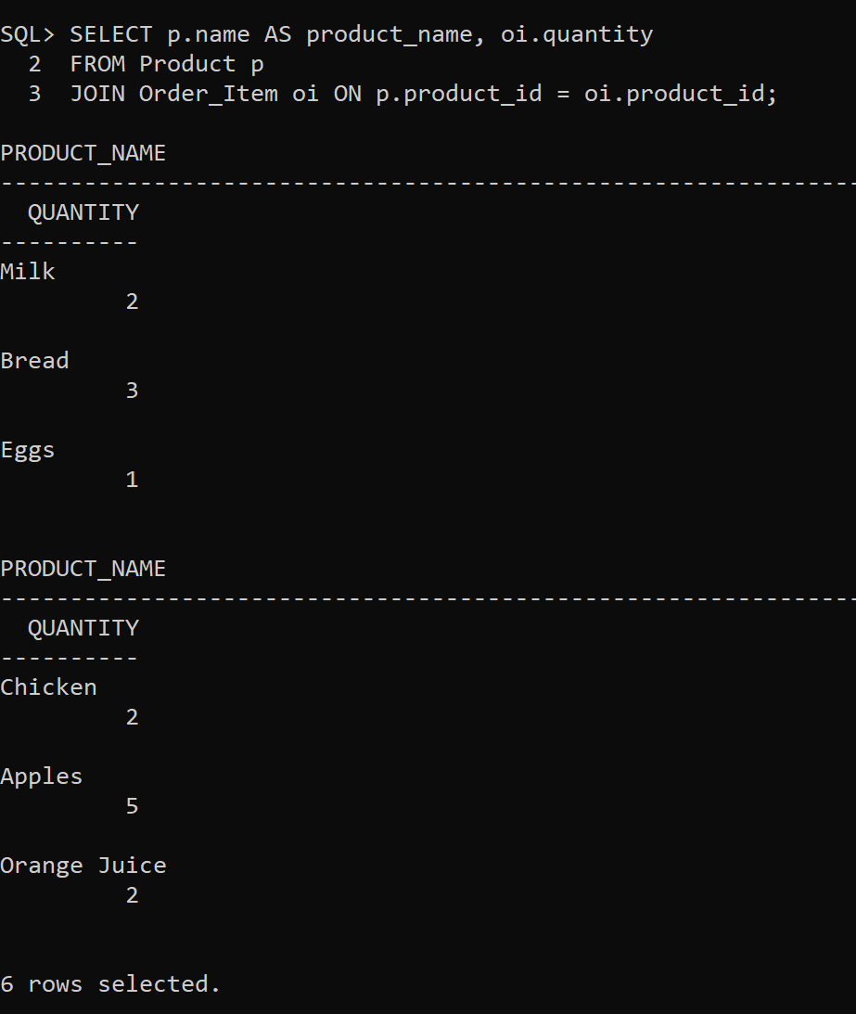

3. List all customers and their orders (**including those who never ordered**).

**Join Type**: **LEFT JOIN**

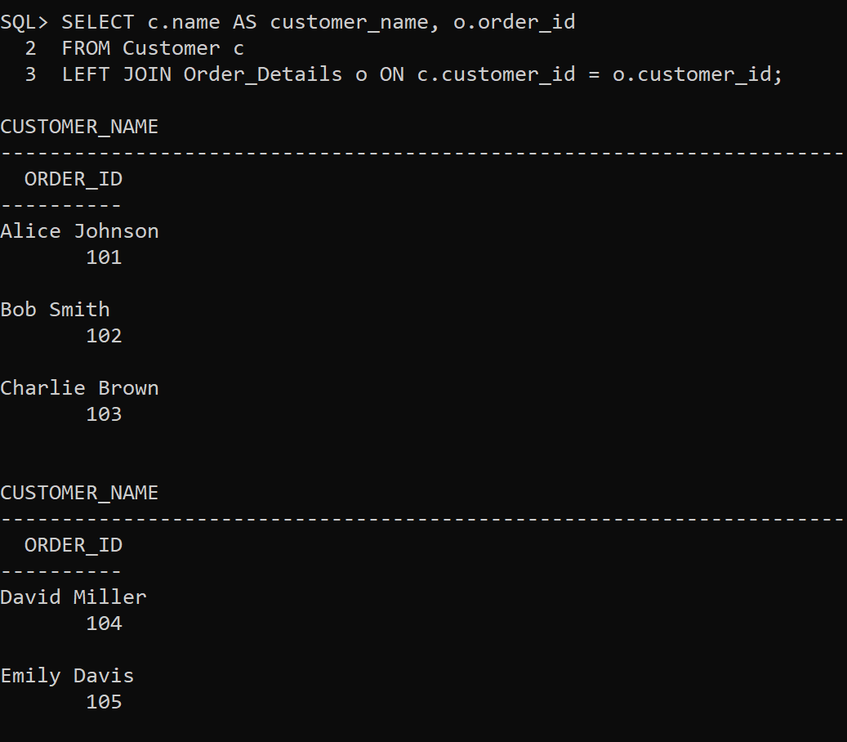

4. Retrieve **all products and their order details** (**including those not ordered yet**).

**Join Type**: **LEFT JOIN**

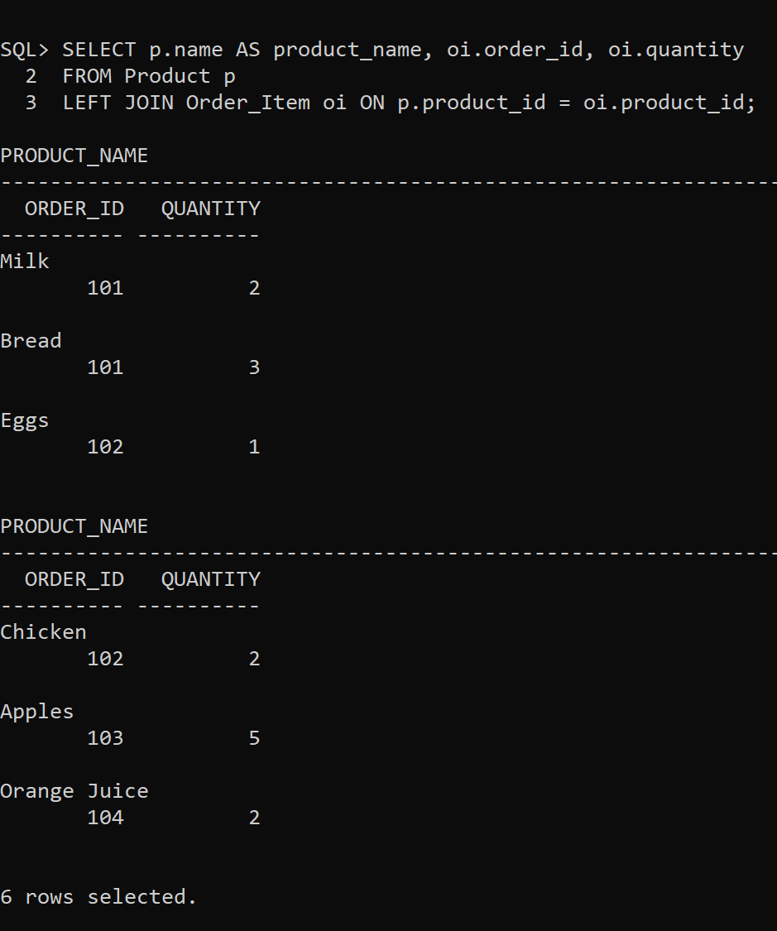

5. Find employees who have **processed orders**.

**Join Type**: **INNER JOIN**

